Experiment No.: 04
Name of the Experiment:
Verification of Node and Mesh Analysis in DC circuit.
Objective:
The study of nodal analysis is the objective of this exercise, speciﬁcally its usage in multi- source DC circuits. Its application in finding circuit node voltages will be investigated.
Theory:
In electric circuit’s analysis, nodal analysis, node-voltage analysis, or the branch current method is a method of determining the voltage (potential difference) between "nodes" (points where elements or branches connect) in an electrical circuit in terms of the branch currents.
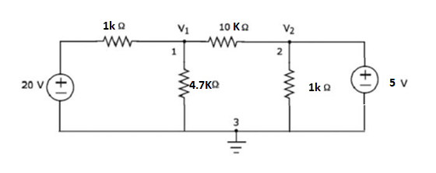
Fig. 4.1.: Nodal Analysis.

Required Equipments:
- Multimeter
- Resistors
- Bread Board
- Connecting Wires
- Power Supply

Procedures:
- Connect the circuit diagram as shown in Figure 4.1.
- Switch ON the power supply.
- Apply the voltage (say 15V) and note the voltmeter readings.
- Gradually increase the supply voltage in steps.
- Note the readings of voltmeters.
- Verify the practical results obtained with theoretical results.

Precautions:
- Follow the lab manual and circuit diagram for using the equipment. Directions in the user manual provide recommended operating procedures and safety precautions.
- Never hurry. Haste causes many accidents.
- Connect the power source last. Disconnect the power source first.
- Use safety googles if necessary.
- Notify lab assistant immediately if any injuries or hazard is happened
- Before connecting the power, check your wiring carefully for agreement with the wiring diagram for an accidental short-circuit and for loose connections.

Data Table:
Applied Voltage V (volts) | Node voltage(V₁) |  | Node voltage(V₂) |  | Percentage Error$= \frac{|Practical-Theoretical|}{|Theoretical|} X 100\%$
 | Theoretical | Practical | Theoretical | Practical

Data Analysis:
- Analyze the obtained data and plot the figures if needed.
- Compare the simulation results with your experimental data /wave shapes and comment on the difference (If any).
Results and Discussions:
- Interpret the data /findings and determine the extent to which the experiment was successful in complying with the goal that was initially set.
- Detect the variation between theory and experimental result if any and propose the ways/procedures to overcome the variations.
- State the particular steps adopted to overcome the deviations between theory and experiment.

Conclusion:
Summarize the experiment and discuss whether the objective was fulfilled or not within a short paragraph.

References:
- Robert L. Boylestad ,“introductory circuit analysis’’, prentice Hall , 12th Edition , Newyork, 2010, ISBN 9780137146666.
- Charles Alexander and Matthew Sadiku , “Fundamentals of Electric Circuits’’ 6th Edition ISBN 9780078028229 .

Pre-Lab Viva Questions:
- Nodal analysis is based on which law?
- What is nodal analysis?
- When do we go for super-node analysis?

Post Lab Viva Questions:
- How do we calculate branch currents from node voltages?
- How do we calculate branch voltages from node?

- Verification of Mesh Analysis in DC circuit.

Objective:
The study of mesh analysis is the objective of this exercise, speciﬁcally its usage in multi- source DC circuits. Its application in finding circuit mesh currents will be investigated.
Theory:
Multi-source DC circuits may be analyzed using a mesh current technique. The process involves identifying a minimum number of small loops such that every component exists in at least one loop. KVL is then applied to each loop. The loop currents are referred to as mesh currents as each current interlock or meshes with the surrounding loop currents. As a result, there will be a set of simultaneous equations created, an unknown mesh current for each loop. Once the mesh currents are determined, various branch currents and component voltages may be derived.

Circuit Diagram:
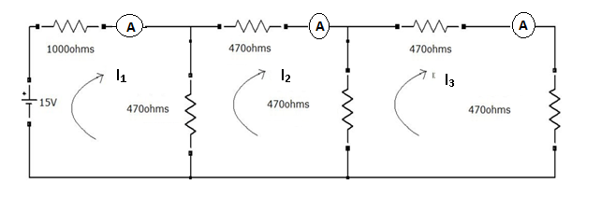
Fig. 4.2.: Mesh Analysis.

Required Equipment:
- Multimeter
- Resistors
- Bread Board
- Connecting Wires
- Power Supply

Procedure:
- Connect the circuit diagram as shown in Figure 4.2.
- Switch ON the Power supply
- Apply the voltage (say 10V).
- Gradually increase the supply voltage in step by step.
- Connect ammeters in the loop and find the currents I1, I2 and I3.
- Verify the practical results obtained with theoretical results.

Precautions:
- Check for proper connections before switching ON the supply.
- The terminal of the resistance should be properly connected.

Data Table:
Applied Voltage V (volts) | Mesh current(I₁) |  | Mesh current (I₂) |  | Mesh current(I₃) |  | Percentage Error$= \frac{|Practical-Theoretical|}{|Theoretical|} X 100\%$
 | Theoretical  I₁= using mesh analysis technique | Practical | Theoretical  I₂= mesh analysis technique | Practical | Theoretical  I₃= mesh analysis technique | Practical

Data Analysis:
- Analyze the obtained data and plot the figures if needed.
- Compare the simulation results with your experimental data /wave shapes and comment on the difference (If any).
Results and Discussons:
- Interpret the data /findings and determine the extent to which the experiment was successful in complying with the goal that was initially set.
- Detect the variation between theory and experimental result if any and propose the ways/procedures to overcome the variations.
- State the particular steps adopted to overcome the deviations between theory and experiment.

Conclusion:
Summarize the experiment and discuss whether the objective was fulfilled or not within a short paragraph.

References:
- Robert L. Boylestad ,“introductory circuit analysis’’, prentice Hall , 12th Edition , Newyork, 2010, ISBN 9780137146666.
- Charles Alexander and Matthew Sadiku , “Fundamentals of Electric Circuits’’ 6th Edition ISBN 9780078028229 .

Pre-lab Viva Questions:
  - On which law is the mesh analysis based?
  - What is mesh analysis?
  - When do we go for super mesh analysis?
  - What is the equation for determining the number of independent loop equations in mesh current method?

Post-lab Viva Questions:
- How do we calculate branch currents from loop currents?
- How do we calculate branch voltages from loop currents?

